ADVANCED SQUAD LEADER SCENARIO ANALYSIS

SCENARIO: AP45 Reaping Rewards
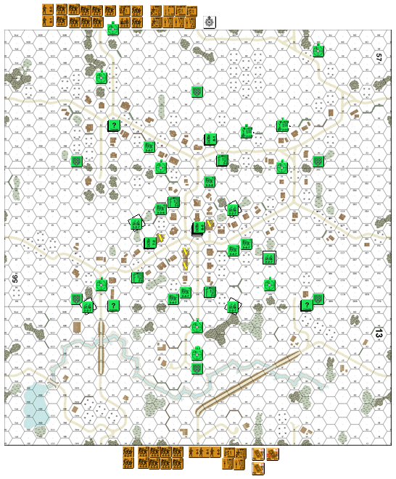
DEFENDER: ROMANIAN

57X3: (3) Dummies 13X10: (2) Dummies 13H10: (3) Dummies

57O1: ? 3-4-7/LMG 56O3: ? 3-4-7/LMG 56R9: ? 3-4-7/LMG
56L8: ? 3-4-7/LMG 56M6: ? 7-0, 3-4-7/LMG 57U2: ? 3-4-7
56T6: ? 3-4-7 56U6: ? 3-4-7 56O10: ? 3-4-7
56R1: ? 3-3-6 56N3: ? 3-3-6 56P9: ? 3-4-7

57P2: ? 8-1, 3-4-7/HMG Boresight 57Y7 56Q5: ? 8-0, (2) 3-4-7/MMG Boresight 13Q7
57J3: ? 3-3-6/60mm MTR Boresight 57X10 57M3: ? 3-3-6/60mm MTR Boresight 57G9

56T10: HIP 2-2-7, 75* ART [O10/S10] Boresight 13Q9
56L4: HIP 2-2-7, 81* MTR [L3/M4] Boresight 56N0 56T3: HIP 2-2-7, 75* ART [T2/U3] Boresight 56X0
13Z10: HIP 2-2-7, 45L AT [Z9/Y9] Boresight 56I9 56W7: HIP 2-2-7, 76LL AT [W8/X7 ] Boresight 56W9

ATTACKER: RUSSIAN

