ADVANCED SQUAD LEADER SCENARIO ANALYSIS

SCENARIO: AP33 Second Cristot
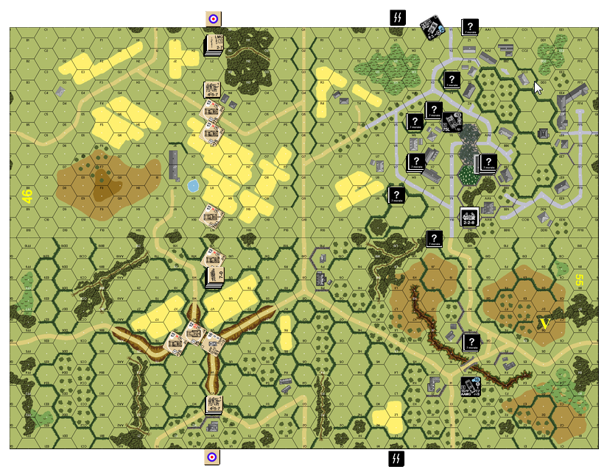
DEFENDER: GERMAN

Stone Rubble: Place in 46Z6, 46Z6, 46Y5

46Z9: HIP 2-2-8, 75L AT PaK 40 [Z8/Y9]
46Y5: HIP JgdPz IV [Z5/Y6]
46X0: HIP Marder III(t)H [W1/X2]
55H3: HIP SPW 251/1 [G3/H2]

46W5: ? 2-2-8 46AA7: ? 9-1, 6-5-8/MMG Building Level 1 46Y3: ? 6-5-8
46Z0: ? 3-4-8 46X4: ? 3-4-8/PSK 46X10: (2) Dummies
55E7: ? 3-4-8, 3-4-8 46V8: ? 3-4-8 46W7: ? 8-0, 6-5-8/MMG

ATTACKER: BRITISH

The carrrier should aim to set up in 55K9 to be able to mortar the church (smoke). Since it is behind bocage it will continually be ble to gain concealment.

The attack is intended to be across a broad front, with the right flank hopefully encountering the least resistance and turning towards the church. Maintain the infantry, because they are the only way to take and hold the victory hexes.

46L1: 9-1, 4-5-7/LMG, 4-5-7/LMG, 4-5-7 55V8: 7-0, 4-5-7/PIAT, 4-5-7/PIAT, 4-5-7
55V2: 7-0, 4-5-7, 4-5-7, 4-5-7 46L3: 4-5-7, 4-5-7

46L4: Sherman V(a) [M4/M5]
46L9: Sherman VC(a) [M9/M10]
46L5: Sherman V(a) [M5/M6]

55V5: Carrier 2-in MTR [U5/U6] 55W6: Sherman Dozer(a) [V5/V6]
55X5: Sherman V(a) [W5/W6] 55V9: Sherman V(a) [U9/U10]

