OVER OPEN SIGHTS
ASL SCENARIO S12

SKYLINE DRIVE, LUXEMBOURG 17 December 1944: Despite numerous pleas from his field commanders, Hitler insisted that the main thrust of the Ardennes offensive not be diminished just to shore up the flanks. Thus, General Brandenburger’s 7th Armee, charged with protecting the southern flank as the panzers advanced in the centre, contained only one Fallschirmjäger division and three Volksgrenadier divisions. The best of the volksgrenadiers – and even much of the 5th Fallschirmjäger Division – consisted of former Luftwaffe ground troops and ex-Kriegsmarine battalions. The 352nd Volksgrenadier Division under Generalmajor Erich Schmidt lacked training, veteran non-coms, or motorized transport. Under orders to bypass defended villages and seize the heights, it crossed the Our river on December 16th in front of the 109th Infantry Regiment and two field artillery divisions situated on Skyline Drive, all part of the 28th Infantry Division. As the 352nd struggled to cross the Our under fire from the artillery, the 109th held its ground throughout the first day, committing most of its reserves to the front line.

VICTORY CONDITIONS: The Germans win immediately upon capturing or destroying all American guns.

COMBATANTS: Bludengutz, American (Defenders) ; Chris, German (Attackers)

Bludengutz: This was the second game that Chris and I played together, and through the medium of VASL. It was a scenario neither of us had played before, and would also be our first Starter Kit 2 scenario – and thus the use of GUNS! I was the defender again, and decided to set up my Guns so that each covered one of the possible Axis routes of entry. Under SSR, I was not able to use HIP for them, which may in hindsight have improved my chances, but one has to work with what one is given, and my Guns were placed as in the following map (Fig. 1). This actually shows the position at the end of the first turn, and demonstrates admirably how a set up to cover all eventualities can easily come undone! Note: In this scenario, grain is out of season, but I had neglected to modify the terrain of the VASL map, so yellow areas, in this case, aren’t!

Chris: SK2, yay! I am really looking forward to this game. It will be my first official SK2 game and I am a bit nervous about those two AT guns. Fortunately grain is in season, well not really but at this stage I thought it was. I chose to split my force into three divisions, each with a leader but with different support weapons.

Division 1 on the left of the board: four 4-6-7 squads and a 2-3-7 half squad. These squads were armed with 3 LMGs, hopefully I would be able to push them past H6 and advance onto the AT gun in K3.

Division 2 in woods J10, K1 and L10: two 4-4-7 squads, a 5-6-7 squad MMG and two 2-3-7 half squads. The half squads will become bait, to draw fire from H6 and/or L7. P7 at this stage did not pose a threat.

Division 3 would use T10 and V10 as cover, with the mortar in T10 laying down damage as wide as possible and the squads from V10 heading towards the AT gun in W4.

Turn 1

Chris: With no Prep Fire to start my 1st turn I decide to advance my forces on the west side of the board. Exhausting one 4-6-7 squad with an LMG and moving into C6 without drawing any fire I decided to do the same with the remaining two 4-6-7 squads. These squads both reached C7 this time drawing fire from H6. Fortunately the MMG did not retain ROF and the stone building provided enough cover to render the American attack useless. With the fire dying down from the east, the 7-0 leader and 2-3-7 half squad moved onto the board and successfully joined the rest of the squads in C6 and C7 respectively.
Having half squads at my disposal I decided to try and draw fire with them before moving in the rest of the squads from my second division. Simon however decided not to shoot at the half squad. I therefore decide to send the second 2-3-7 squad in. Drawing fire with no effect I now was able to advance with my 4-6-7 carrying an MMG towards L7.

Having seen the successful assault from the other two divisions, Division 3 were ready to go! Moving two 4-4-7 squads onto the board and into W9, followed by another two 4-4-7 squads on V10, I decide that nothing will stop Germany from claiming a victory today. Famous last words! The first four squads were able to move onto the board unhindered, because of grain LOS hindrance, right? Wrong, for this mistake the 8-0 Leader paid with his life. Moving both 4-4-7 squads and their mortar and a 2-3-7 half squad onto T10, resulted in a unhindered -1 shot from O4. It is uncertain if the 8-0 leader heard the shot fired from O4 as he was eliminated from T10. The broken squads waited for another shell from the 155, but fortunately the American gun failed. Having my stack reduced to 1 broken squad and 2 broken half squads made the successful advance in the west and malfunctioning gun look mundane.

I decided to Advance Fire all available squads from Division 1 into H6. This resulted in both the leader and squad breaking. Division 2 Advanced Fired into L7 breaking the 5-4-6 squad.

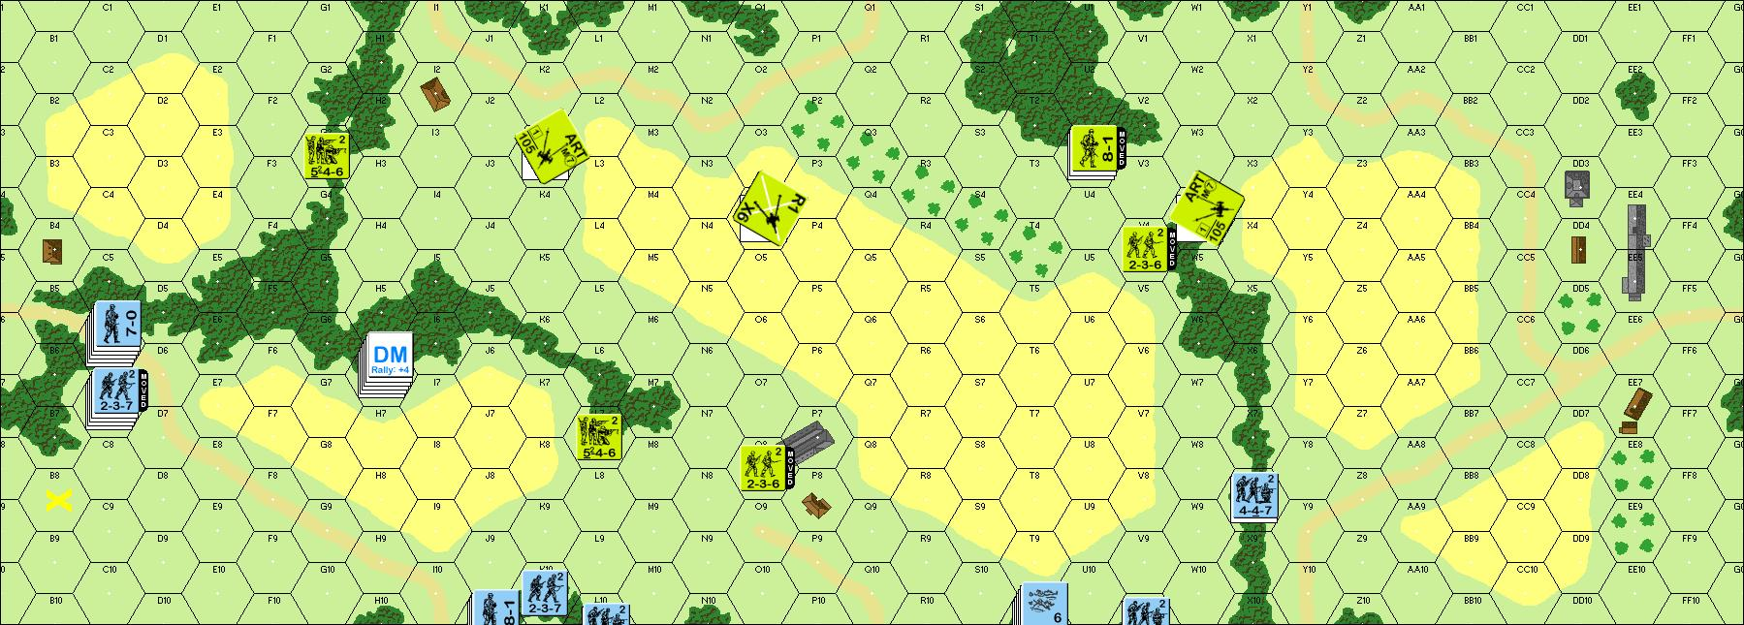
Fig. 1; End of T1

Bludengutz: Chris chose to concentrate his forces in the south and west, making my 105 covering the eastern flank completely redundant. I had some success with my 155 in the centre at first, targeting his stack entering at T10, killing his SMC, breaking and reducing through ELR the two accompanying MMCs, and pinning one. All with a single shot! Which was just as well, as under Intensive Fire, the gun promptly malfunctioned. The rest of his troops either Assault Moved into the woods on the southern edge, or advanced in the cover of the woods to both my west and south-east. I moved my forces on the right, namely a solo HS and the HS manning my 60MTR and their accompanying SMC, slightly to the rear, to give them a chance to make LOS in the coming turns. The 155 stayed stubbornly jammed, and fire from Chris’s MMG and squads in the building at C7 broke the SMC and HS manning my MMG at H6.

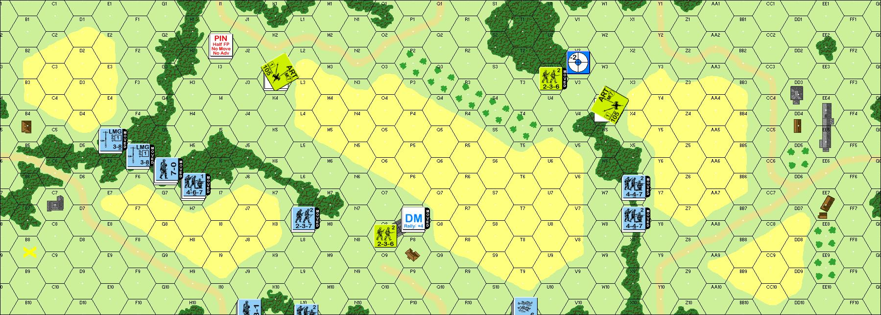
Fig. 2; End of T2

Turn2

Chris: Having been able to keep the American leader and squad broken in H6 in my Turn 1 Defensive Fire I decided to take the guns from the west and east. With only the squads in T10 to rally I decided to rally the 4-3-6 squad manning the 50inch mortar. Rolling a 5 the squad mustered enough courage to lift their heads and set the mortar to aim at U3. Their newfound courage must have been the fact that the 155 ART Gun in O4 could not be repaired by the Americans.

The following Prep Fire saw the 4-3-6 squad managing to keep ROF on U3 breaking and killing the 8-1 leader, accompanying squads and SW. I decided to advance the four 4-4-7 squads by moving them onto W4 and L6, hoping to reach the objective in the next turn.

On the western part of the battlefield things were still looking good. I decided to move my forces in a column using the defensive cover provided by the natural line formed by the woods. With the squad in O8 only in long range, I decide not to worry about them for this turn. I would use the 8-1 leader, 4-6-7 squad and MMG and two 4-4-7 squads to advance onto K3. To do this I would need to move to K6 hoping to use the cover provided with the above squads.

The following Defensive Fire saw none of the American squads breaking and the Germans returned the favour.

Bludengutz: Turn 2 saw the Germans advance steadily toward their objective, my guns. With one of the squads in T10 rallying, Chris turned his 50MTR on my MTR in U3. The first hit broke and wounded the SMC, and broke the HS. Keeping ROF it scored a KIA and wiped the lot out. The broken stack in H6 came under fire again, the HS being killed and the SMC being broken and wounded. He then failed his Wound Severity roll under Advancing Fire, and joined my growing dead pile. For my part, the 155 was permanently removed for rolling 6 in the Rally phase, its crew running for the apparent safety of the 105 at K3. The HS on my right moved into the woods to its north, where it survived the attentions of the German 50MTR (especially when it was found to only have 2FP! but it was too late to resurrect my MTR and stack), advancing out of Acquisition. The MMC at L5 was broken, but managed to survive Interdiction and take shelter in the building at P6. My only other full MMC, in the woods on my western flank, was also broken, but managed to shelter in the hut at I2. The German advance continued!

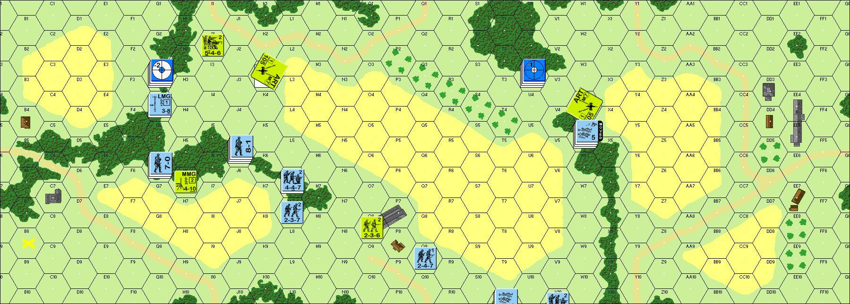
Fig. 3; Start of T4

Turn3

Chris: My Prep Fire phase resulted in breaking the one of the crews in K3, but apart from that nothing else. What a dismal performance.

Continuing my advance on W4, one squad at a time, I hoped to again draw fire from and there by exhausting the American’s defensive fire. This move resulted in two squads breaking.

Having a 2-3-7 squad available I decided to rush the 105 ART Gun in K3 from K6. The result? Less than desirable as the squad got eliminated without much ado.

With the ensuing Advance Fire resulting in no effect in the west, I had however been able to break the crew in W4 with the two remaining unbroken squads. This Gun would be fall in to German hands in the Advance Phase.

Bludengutz: Chris continued to press hard on my defenders, his troops in the south coming out of the woods, and the crew of my eastern 105 breaking and running to the woods at U3. My broken MMC at P6 was also forced to rout, and fell to Interdiction. One of the two Crews with the western 105 was broken and also fell to Interdiction. However, the other crew distinguished themselves by turning their gun on the Germans in the western woods, keeping ROF and breaking two stacks. The MMC at I2, having rallied, also eliminated a German HS under Defensive Final Fire as they rushed the American field piece. The HS at U3 also exacted a measure of revenge, and forced a German MMC off of the 105 at W4 by breaking it. However the elation this brought was to be short-lived.

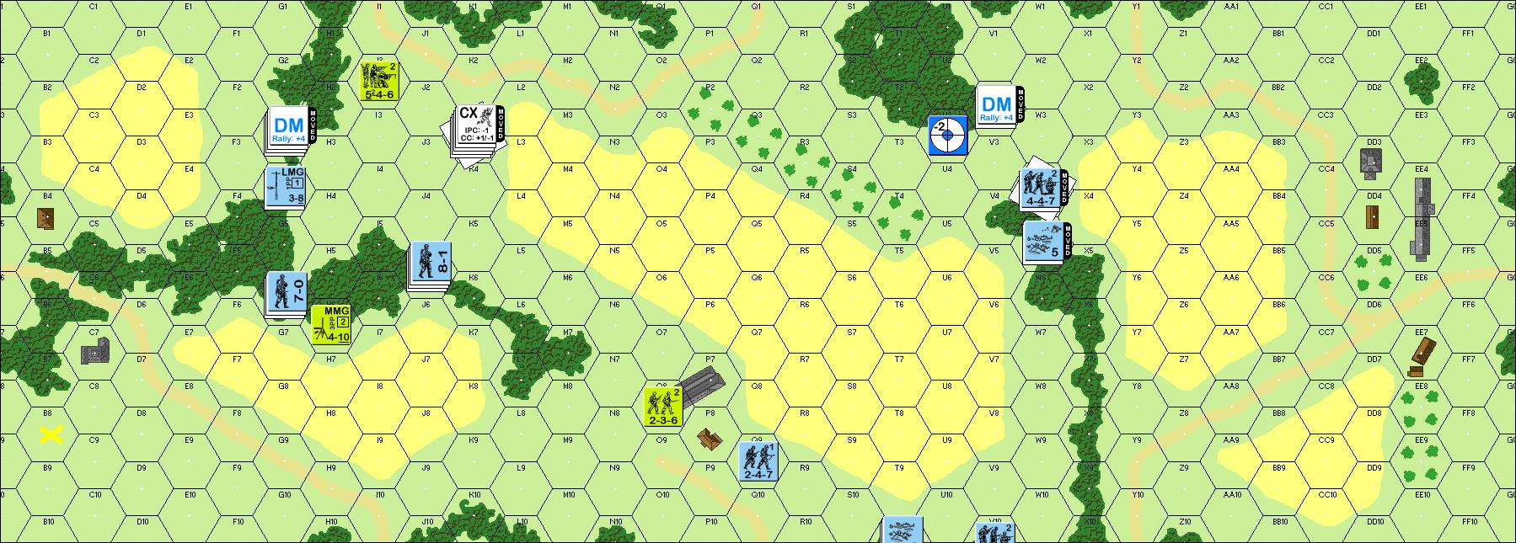
Fig. 4; Game over! – End of Axis T4

Turn 4:

Chris: To Prep Fire or not, that was the question. Prep Fire from the mortar in T10 eliminated the crew in U3. This made the Gun in W4 definitely remain in German possession. On the western side of the board Prep Fire from G3, G6 and J5 resulted in nothing, again.

Now or never, I could not have the American’s bring in their reinforcements. I decided to rush the two 4-4-7 squads onto K3. With luck being on their side the two squads reached the crew and gun and were able to eliminate the gun in the ensuing Close Combat. Objective reached.

Bludengutz: During his Player Turn, Chris once again fired his 50MTR on the MMCs in U3, killing the Crew, breaking the HS and reducing them in quality as well. It was a simple move for the unbroken MMC at W5 to move onto the abandoned gun at W4, and a well-timed dash under CX by the squads in L6/L7 brought them into Close Combat with the crew of the remaining 105. A short, bloody encounter followed, and the Germans were in possession of that piece too. In the space of one Player Turn the game was brought to a swift conclusion, the forces of the Third Reich victorious!

AFTERMATH: By the next day, however, company-sized German forces were making good progress between the American strongpoints, spreading into the rear areas, and menacing the gun positions. Early on December 17th a battery of 105mm howitzers from the 107th Field Artillery Battalion positioned on Skyline drive came under small arms fire from German patrols. Later in the day, an entire battalion of volksgrenadiers from the 915th Regiment attacked the 105mm battery and a neighbouring battery of 155mm howitzers from the 108th Field Artillery Battalion. Firing over open sights and fighting as infantry in self defence, the cannoneers inflicted heavy casualties but could not drive off the attackers until relieved by a scratch force led by battalion commander Lt. Col. James C. Rosborough. The batteries were saved, but their once-formidable positions were now untenable.

Bludengutz: Well, the scenario almost went the way of history! My cannoneers were valiant in defence, and inflicted some casualties, but were hampered from the start by my initial set up. In trying to cover all angles, my forces were spread far too thinly, and the Germans achieved their objective so swiftly that I was prevented from bringing on my T4 reinforcements! I should have kept my guns closer together, so that they could cover all avenues of approach and give each other some degree of mutual support. In an effort to hold up the attackers, I placed my infantry too far forward and spread them too far apart. Chris, however, played a blinder, concentrating his forces to deal with one side of the board first, and providing his weaker thrust with good support from his mortar. All in all a great game, with some memorable moments and plenty of lessons learned. A re-fight will go in my favour for sure!

Chris: Although victorious I am not too proud of my victory. Had I not stuffed up the FP of my mortar, Simon would have been able to hold off my squads in W4 longer. This would have allowed him to bring on his reserves in the American Turn 4. A re-fight is therefore rightly deserved.

